Middle East  Studies Center | 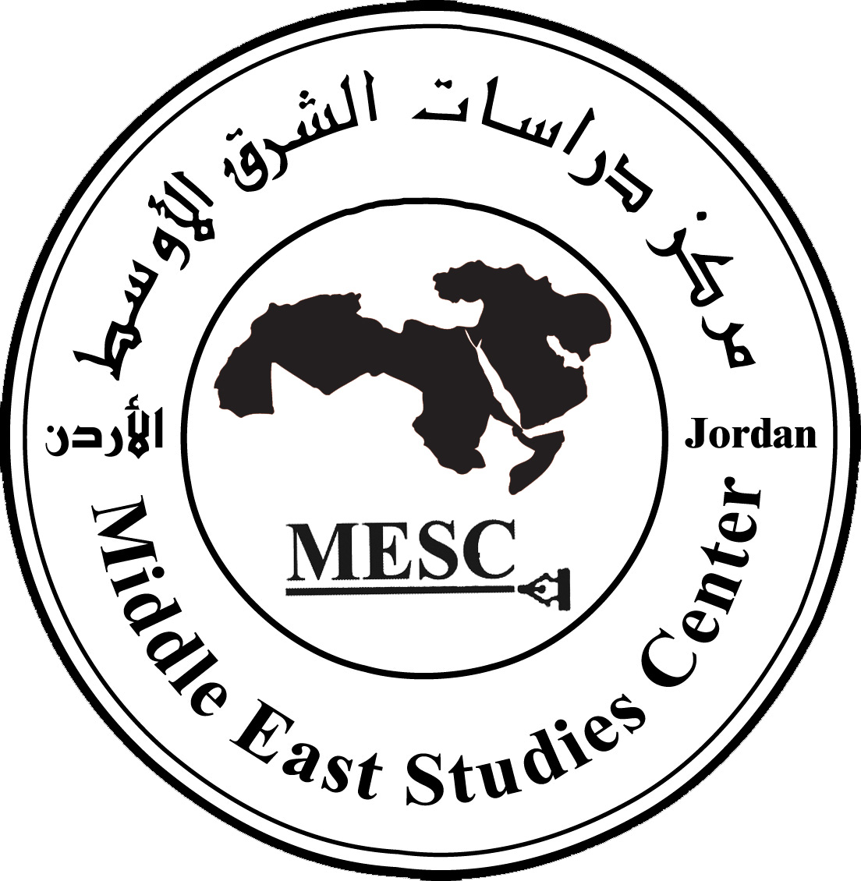

Primary draft

Workshop On:

The Hamas Victory in the Palestinian Parliamentary Elections of 2006: Impact on the Cause and Conflict in the Region

Middle East Studies Center (Amman)
January 2006

Contents

• Inroduction 2

• The Importance of the Palestinian Election 3
• Why did Hamas Win and Fatah Fail? 3
• Public Opinion 6
• The Consequences of the Palestinian Election 8
• Challenges and Directions 9
• Hamas' Duties and Possible Obstecles………….10
• Recommendations 11

- Introduction

The Middle East Studies Center (MESC) held a symposium on 26 January, 2006 to analyze the results of the Palestinian parliamentary elections and the surprise victory of Hamas. It provided insight into the reasons and consequences of the results and discussed the challenges that Hamas would certainly face after gaining the leadership of the Authority from Fatah. The workshop was attended by academics, politicians and experts.

The symposium was critical in investigating the future vision and the real reasons behind the Hamas victory and Fatah's failure. It also sought to evaluate the last Palestinian presidency, municipal elections and the role of public opinion and discussed the impact of the poll on the next election, investigating Hamas' relationship with countries such as Jordan and Egypt, international cooperation with Europe and America, the position of the Quartet committee and Israel, the executive committee of the Palestinian Liberation Organization, and the possibility of establishing a government based on real partnership among the different factions after decades of Fatah rule.

The importance of the Palestinian Election

The elections are considered first in which all of the Palestinian factions and parties took part in, and from all intellectual and political stances and trends, save for Al Jihad Al Islami.

Many felt the results of the previous municipals election where Hamas received 35% to 40% of the votes and seats, didn't reflect the political direction of the Palestinian community, as it did in Australia when the Labor Party won in the municipals election while the Conservative Party won in the legislative election. The results of the Palestinian legislative election emphasized the general direction of the municipals election since it was controlled by Hamas while Fatah retreated. The unexpected differences reached more than 27.6% of the votes and seats between Hamas and Fatah in favor of the former; Hamas got 60.6% of the Council seats while Fatah 32.6%.

The results of the elections demonstrated a living example of democracy not found in the rest of the Arab countries. It can be said from now on Israel is no longer the single democratic country in the Arab World. This election served an important lesson for the Arab Nation. It proved that the Arab people are able to exercise democracy even if their country is under the occupation and proved that democracy can function effectively in the region.

This meant also the Abu Mazen government presented a successful indication of carrying out its obligation for a democratic and fair election. The armed factions maintained a calm posture without any violation which enhanced the democratic process and presented a brilliant idea for the Palestinian people who elected according to the presented agenda and political factions. Votes were not bought as it happens in some Arab countries. Hence, the Washington Post said: the Palestinian people proved they couldn't be bought?

Why did Hamas Win and Fatah Fail?

Participants in the workshop discussed the reasons behind the Hamas' victory and of Fatah's failure, they concluded that the polling results showed factors that led to both. They are:

- Factors Relating to the Hamas Movement
- Factors Relating to the Fatah Movement
- Conditions and the Surrounding Environment

Factors Relating to the Hamas Movement

- Its role in the resistance against occupation for Palestine which lead to its increased popularity and the success of its political program. A great majority of Arab people support the resistance in Palestine. Hamas succeeded most because of its tangible social activities and benefits for the people in Gaza.

- Its Islamic influence in popular culture has had a deep effect under the banner of nationalism and popular support. Islam came to encourage resistance through the provision of social services.

- Hamas provided a comprehensive program on the social and political levels. It is not involved in practices of corruption as the Fatah Movement allegedly is in the eyes of many analysts and opinions of many Palestinians.

- Hamas provided many services to the Palestinian people in aid and in different social services especially to those injured and in need. It also presented its program earlier by its participation in the municipal elections stressing the provision of service that played a crucial role in the gathering of support for the organization. Aid from Europe and America was even distributed. Most of the Islamic movements in different countries also followed suit as an alternative for fighting corruption.

- The organization and discipline among Hamas which the movement instilled in its members and the way it approached issues was different to that seen by Fatah, which was bogged down by splits in its electoral lists and candidates. This encouraged the Palestinian street to elect Hamas for the new stage.

- The American and Israeli positions in refusing to deal with Hamas constituted a counter-reaction for the Palestinian voters who chose what America and Israel refused to recognize.

- Hamas provided a full political program, addressing crucial subjects as the truce and negotiations through a third party. At the same time, Hamas is keeping the issue of resistance as an option as long as Israel continues its occupation. The Palestinians realize Hamas understand the international environment, they have come to trust the movement to bear the responsibility and represent them through resistance and political means.

Factors Relating to the Fatah Movement

- The absence of a symbolic leader like Yasser Arafat lead to deep schism in the Fatah movement, since the late Palestinian President had the ability and knack to bring together different trends, sections and views within the movement which Abu Mazen lacks. This was shown clearly in the "Marwan Al Barghouthi list" which contributed to the rift. Although Fatah exerted much effort to settle its internal problems, it didn't success. The opposing trend in Fatah didn't give it any support: So the outcome, Fatah received 40% while Hamas 45.5%.

- Increasing corruption in the Palestinian National Authority for many years affected the popularity of Fatah. Many are calling for change, firstly inside the movement and then in the Palestinian street. Some even concluded Hamas did not receive a higher percentage for its electoral program but as a protest vote against Fatah.

- Palestinians voted against a Fatah political program that failed to address the peace process. Israel did not provide any concessions parallel to those presented by Fatah through; as recognizing Israel, and its right to occupy 78% of the Palestinian territory.

- Absence of democracy in the Fatah Movement since its last major conference held in 1988. As the result, it leadership and framework remained the same.

Environment

The general condition in Arab countries which refused American intervention in the region enhanced the opportunity for Hamas to gain the confidence of the Arab street and Palestinian voters. Although the Palestinian voters realized the difficulties that would be posed by the suspension of western aid due to the American and European declarations, they chose the resistance program represented by Hamas movement.

The passive position of Israel and the United States in dealing with the Palestinian Authority, especially under the Abu Mazen leadership, weakened Fatah and decreased the possibility of persuading the Palestinian street to support it’s version of the peace option. Instead the Palestinian people came to favor Hamas whose positions are markedly different than those put forward by America and Israel. Hamas also exploited the weaknesses in the programs and stances of the other Palestinian factions as it was shown clearly in the election; its program was seen as the most viable and effective alternative. As the result, the alternative to Fatah was Hamas.

The conditions that called for reform and election enhanced the convictions and ideas which suggested that militant work is not enough but needed to be enhanced by political action to protect the resistance and the national affairs of the Palestinian people.

The superiority of Hamas is seen to be a part of the political progress of the Islamic movement in the region. The Legislative Election proved that there is widespread public support for the programs and leaderships of the Islamic movements in many Arab and Islamic countries.

Public Opinion

Most of the public opinion polls displayed wide margins of differences in the results and expectations. Some polls were way of the mark which increased the challenges for Hamas. Opinion polls in Palestine are still weak and even a threat for fair results. Although the public opinion polls experience are welcomed, the predictions are leaving something to be desired, sometimes reaching a difference of 25%, which is considered very high in contrast to the international figures of between 3% and 5%.

Election Consequences

First: On the Palestinian Level

The results of the election emphasized that the Palestinian community witnessed critical transformations; unknown social forces were unleashed as civil society was geared towards the electoral process.

Resistance was expected to continue alongside the political dimension being adopted despite the fact that Israel was expected to increase its violence and continue to arrest or assassinate Hamas' leaders specially those who have since become members of the Palestinian Legislative Council.

On the other hand, Fatah might now be able to look at the new situation afresh and deal with the pressing issue of fighting corruption more effectively. It could very well exit from the Palestinian work in the next stage.

Hamas might succeed in making a change in the structure of the Palestinian Liberation Organization to become more balanced and represent all of the Palestinian people more effectively in Palestine and in diaspora.

Second: On the Israeli Level

The Hamas victory was thought likely to move the Israeli voters to the right in the March 2006 Israeli General Election, and show a big win for Likud and the other extremist parties. Instead Kadima, itself a split from the Likud, won with a surprising majority, and a massive defeat for Likud of only 13 seats. Many believe that the Israeli government is now using the Hamas win to stall on the peace process.

Third: On the Arab Level:

On the regional level, it is expected the Arab countries to express worry about the election. So Arab governments might exert much pressure to prevent the occurrence of similar free elections as to what has happened in Palestine.

Other expectations include the radicalization of the political forces in Syria, Lebanon and Jordan; the Islamic movements in these countries may utilize the Hamas experience to reach power. The Palestinian election will also change the trends in what is seen as the push for a moderate political Islam and alter the perspectives of the forces of resistance in reaching Parliament and even become the ruling governments in different Islamic countries.

But it is also expected that Arab governments will crack down on nepotism, corruption and graft in the different institutions of society to stem the tide of political Islam because of what happened in the last Palestinian election.

On the other hand, the results proved the decision of the Jordanian government to close Hamas' offices in Amman and prevent its leaders for returning to Jordan was a wrong decision. The excuse put forward by the government in Jordan was it does not allow any parties of other countries to operate in Jordan. But it is expected Jordan will reconsider its relationship with Hamas which is the choice of the Palestinian people for the next four years.

The Hamas' leadership will provide the opportunity for the Arab countries to insist on the upholding of the wishes of the Palestinian people and its official position. This will help in resisting the pressure for free normalization and the provision of more concessions to Israel.

Fourth: On the International Level

- Hamas' success will lead to decreasing pressure on Syria and Iran.

- The United States will reconsider its relationship with Damascus and use it to establish joint positions on Hamas.

- Although the public declarations of America, Europe and Israel are of worry to the Hamas' victory, the United States more than once, declared it is possible to establish peace with the presence of Hamas. American President W. George Bush also stated he will accept a government led by Hamas, if the organization abandons its program for the destruction of Israel.

- It is expected Hamas will deal with the international community wisely and it is also expected the international community will reconsider its position toward Hamas once stability sets in and its political program for reform in the next three year starts to bear fruit.

- The Hamas victory will decrease the American war on terror, since Hamas could win more support on the public level, although the United States still considers the organization as a terrorist movement but the win is complicating the issue for America and its allies. The Americans are worried about their interests in Iraq and Afghanistan and they could well be considering in dealing with the different resistance movements including the Islamic organizations, rather than face continuing military threats and death tolls.

- Challenges and Directions:

In spite of its failure in the election, Fatah continues to have much political weight in the Palestinian arena. Some of its members are openly seeking to obstruct the formation of a Hamas-led government especially when they insist that their organization would not participate in a government of national unity.

Possible Scenarios of Government Formation:

- Hamas will form a government

- Hamas will support an independent candidate and form the government

- Hamas will accept the formation of the government by Fatah, but within Hamas' programs.

Some participants expect Hamas to provide a more pragmatic program in line with the Palestinian general context, by being diplomatic in language, tone and having many options. It is thought Hamas could become nearer to the American and European views and establish a dialogue with them. Hamas also could look at the experiments of different Islamic parties like HizbAllah in Lebanon, Justice and Development Party in Turkey, National Islamic Front in Sudan, and gain from their experiments.

Participants in the symposium urged Hamas to be wise as the Palestinian political scene from now on would require delicate balance as the president of the National Authority continues to be from Fatah and responsible for security, while Hamas will manage the government and the Legislative Council. This last aspect is critical because the government has responsibility over the Palestinian street and the protection of civil society and over the establishment of relations, internationally, the region and Israel.

Participants agree Fatah will be tactical arguing for non participation in the government to blackmail Hamas, arguing the Islamic movement does not have the sufficient experience and qualifications to form and run a government. On the other hand, Hamas has to make a counter tactic by seeking to allow all parties a share in the government. It also crucial to go for a strategy of adopting many tactics which it has pledged to do since the Cairo Declaration in March, 2005.

Participants also urged Hamas to revise all of the political agreements with the occupier without rejecting them at once, urging them to reconsider the overall Palestinian interests. They expect Hamas to sort out the difficulties in dealing with the security forces which is supposed to be under the Ministry of Interior. They don't know whether the Ministry of Interior will be under the new government or under the direction of Abu Mazin. Fatah still holds the support of a quarter of the Palestinian electorate, due to the results of the election, and has also control of the security forces.

Participants urged Hamas to concentrate on the basic issues of Palestinian sufferings, of occupation and unemployment, and not just pay attention to the social and cultural aspects. Hamas has to deal with many consequences especially the legal and political aspects related to the Palestinian Liberation Organization, the legitimate representative of the Palestinian people. It is difficult for the Legislative Council to change agreements authorized by the PLO and not from the Authority or the Council.

There are many problems regarding the difference of competences between the Council and the Liberation Organization. This might be settled by Hamas' entrance to the Organization and revising the National Covenant. The participants also emphasized the other consequences regarding Hamas' presence in the legislative and executive authorities, since it has to follow the legal decisions of the United Nations especially on the issues of borders, refugees, and Jerusalem.

Regarding negotiations with Israel, Hamas initially accepted indirect negotiation, due to its primary declarations. This indicates a consistent stance against direct negotiation with Israel since it has not provided any real concessions but this means also that this point is still open.

Hamas has to calm the Palestinians, Arabs, and the world to guarantee the trust of its friends and weaken the reactions of its enemy.

Hamas: Duties and its Possible Obstacles

Participants discussed the duties of Hamas and its possible obstacles. They include:

- Rebuilding the Palestinian house on the basis of national unity inside and outside Palestine by the Liberation Organization and others.

- Starting comprehensive reform as part of the democratic process and end corruption since the Authority has not able to do that. Palestinians certainly want that and do not want to use it as an excuse to resist occupation. That's why the Palestinian street elected Hamas to fight corruption as part of its resistance and reform program.

- Hamas may not implement its program since it faces many obstacles. In the past, Israel created many obstacles against Arafat to frustrate him and is it possible now it might let Hamas succeed? It seems that Hamas will face a crucial test, much problems and challenges in the near future.

- The international and even Arab media will try to warn against Hamas and the dangers of its new direction in reform, resistance and fighting corruption. It will try to create a public and international opinion against these, but the Hamas' success, in its practical realistic program, will destroy these campaigns and increase the convictions of the Palestinian masses toward consolidating support for this Islamic organization.

Recommendations

Participants in the workshop also analyzed in depth the consequences and the effects of the elections on the Palestinian, Arab, and Israeli sides and its impact internationally. Recommendations are:

- Participants agreed Palestinian forces in the PNA must merge into one, the same for the different security forces, emphasizing the formation of a Palestinian government that includes all parties.

- They advised the Arab countries and Arab League to support the new government to achieve a new political transformation and be a stepping stone to democratization in the Arab world whilst urging these countries to hold democratic elections.

- They argued Hamas should freeze the peace process from between six months to a year to reorganize its internal position and assure Arab countries of their stance in the light of the American conditions and Israeli elections. At the time of the American and Israeli elections the Palestinian cause will be marginalized, it will also not be discussed except if it used as a pressure point or as a high diplomacy stake. The Palestinians and Arabs need to crystallize their positions and visions to revise agreements on the legal and political aspects of the Conflict.

- Hamas has already been advised to give assurances and clarifications regarding their resistance, political views and their willingness to initiate a new national agenda.

- Hamas has been advised to deal with those Fatah members who want to continue to participate in the running of Palestinian society, draw up Palestinian policy and/or resist the occupation.

- Participants argued what is now needed is more Palestinian, Arab, and international investments in the Palestinian territories. Hence, the Arab League should encourage all parties to provide support towards this.

- They encouraged Hamas to apply more political pressure to reform the judicial, executive, and legislative organizations under Palestinian Authority control.

- Participants emphasized Hamas must from now on balance its role in the official PNA and as a resistance movement.

- They emphasized on ending factional alliances inside the security sectors to represent a one national security apparatus.

- They argued for the start of broad negotiations and deal seriously with the Arab world and international system.

- They suggested a call for the assistance of the great powers as China and Russia and other developed countries regions such as Turkey, Iran, East Asia and Latin America in ironing out disagreements with American policy over the resolution over the Conflict.

- They advised Hamas to rearrange its internal and external priorities and balance between the resistance program and the peace settlement as well as give an opportunity to all parties to participate in the next Palestinian government.

Amman
26 January 2006

* Prof. Ahmad Said Noafl ( Professor of Political Science/University of Al Yarmouk), Dr. Anees Qasem ( Lawyer and Legal expert), Dr. Sabri Somayra ( Professor of Political Science /University of Jordam) Mr. Faleh Al Taweel ( Member of the Jordanian Upper House and former Ambassador ), Mr. Arafat Hejazi ( Journalist and advisor of late Palestinian President Yasser Arafat), and Layla Khaled ( Politburo member of the Popular Front for the Liberation of Palestine and Member of the Palestinian National Council), Mr. Shaker Al Gohary ( Journalist), Mr. Hassan Haidar (Director of Al Quds Press Agency in Amman) Mr. "Muhammad Shareef" Al Jayosi (Journalist), Mr. Muhammad Al Abbasi (Associate researcher of the Middle East Studies Center) and Mr. Sameer Yaseen (Associate researcher of the Middle East Studies Center)

